- System Commands:
- whoami:
- Shows the current logged-in username.
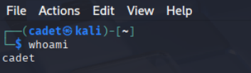
- hostname:
- Displays the system’s hostname.
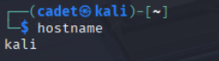
- uname:
- Shows system information (use uname -a for all details).
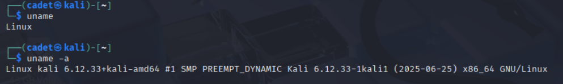
- uptime:
- Displays how long the system has been running.
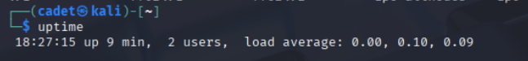
- Date:
- Shows or sets the system date and time.
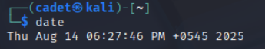
- Cal:
- Displays a calendar.
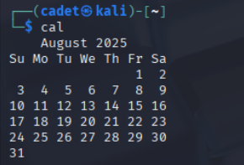
- Who:
- Shows who is logged in.
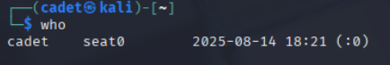
- W:
- Displays logged-in users and their activities.
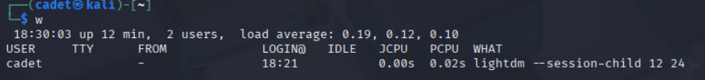
- Id:
- Shows user identity (UID, GID).
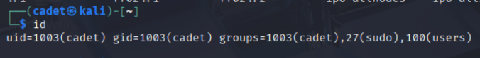
- Df:
- Shows disk usage by filesystem.
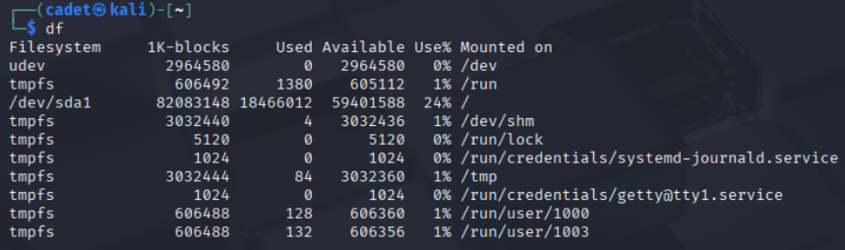
- Du:
- Shows disk usage of files and directories.
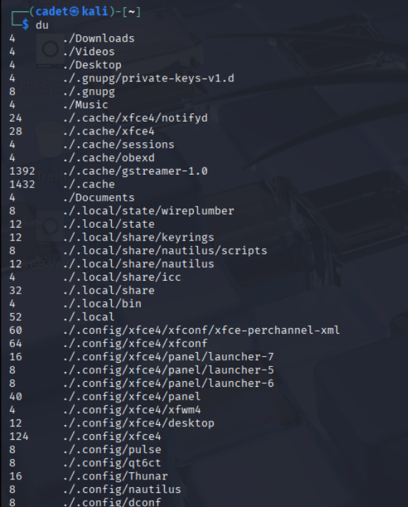
- Free:
- Displays memory usage.
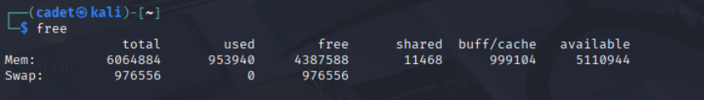
- Top:
- Shows running processes and system resource usage.
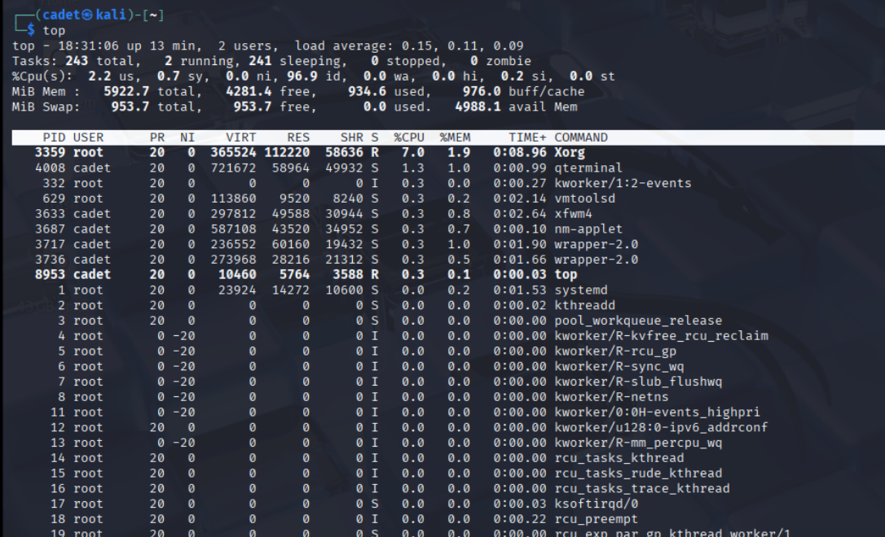
- Uptime:
- Displays system running time and load average.
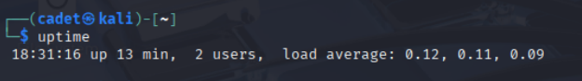
- Ps:
- Displays running processes.
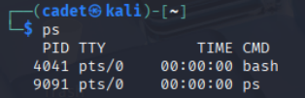
- History:
- Shows command history.

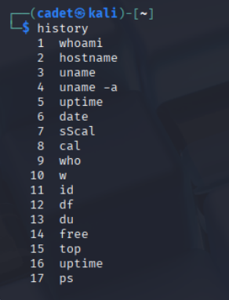

- Clear:
- Clears the terminal screen.
- shutdown
- Shuts down or reboots the system.
- reboot
- Reboots the system.

